Users still stuck in the mud?

An analysis of Meta’s 2026 changes to its consent-for-ads mechanism against EU law

March 2026

Why it matters to consumers and our call to authorities

The European Consumer Organisation – BEUC, takes the view that Meta’s latest changes on its ‘consent-for-ads’ model would still not meet the requirements laid down in EU law, especially EU Regulation 2022/1925 (the Digital Markets Act - DMA), EU Regulation 2016/679 (the General Data Protection Regulation - GDPR) and EU Directive 2005/29 (the Unfair Commercial Practices Directive – the UCPD). Several crucial issues remain unsolved, including the ability of users to provide free, specific, informed and unambiguous consent given Meta’s extensive data collection, and the continued use of non-neutral language and interface design techniques which undermine the free choice of users.

BEUC calls on:
- The European Commission, where appropriate, to impose periodic penalty payments on Meta in accordance with Art. 31 of the DMA and urgently bring it into compliance with the law.
- The Consumer Protection Cooperation Network (CPC-Network) to conclude its ongoing coordinated action against Meta which started in 2024 and to ensure that Meta fully complies with the EU consumer law acquis.
- Data protection authorities to continue their investigations into Meta’s data collection practices to ensure they comply with the GDPR and promptly issue a decision.

Contents
Introduction 3
1) An assessment against the Digital Markets Act 5
What the DMA requires 5
What has improved and what remains insufficient 5
2) Assessment against the GDPR 8
What the GDPR requires 8
Data minimisation 8
Informed consent 8
Freely given consent 9
3) An assessment agains the Unfair Commercial Practices Directive 10
Annex 1 11

Introduction
In November 2023, Meta introduced a binary pay-or-consent mechanism (Fig. 1) for Facebook and Instagram users. The latter were asked to either consent to Meta’s full personal data processing activities (the ‘personalised ads option’) when using Facebook or Instagram, or to pay a monthly subscription (the ‘no-ads option’) to use an ad-free service.

Fig. 1: first screen of Meta’s ‘pay-or-consent’ user flow rolled out in November 2023
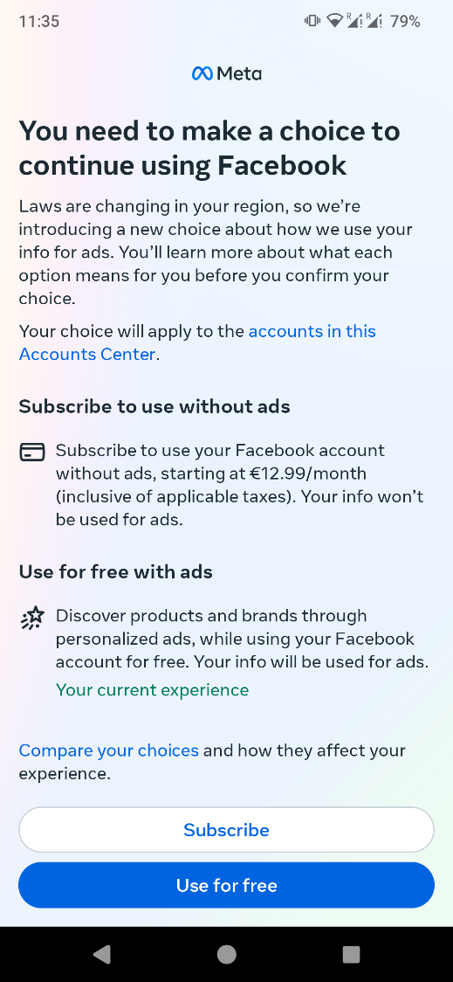
This mechanism was primarily a response to the incoming DMA which prohibits several large tech companies (known as gatekeepers) from employing users’ personal data gathered from third parties for ad purposes without obtaining valid consent under the conditions laid down in the GDPR. The DMA built on a 2019 decision issued by the German competition Authority (Bundeskartellamt) in 2019 which prohibited Meta from combining personal user data from different sources without user consent.
Meta’s pay-or-consent model proved controversial. In November 2023, BEUC and 19 of its members filed a complaint with the Consumer Protection Cooperation Network (CPC-Network) raising several possible infringements of EU consumer law. In addition, in February 2024, BEUC coordinated the filing of several complaints by its members with national data protection authorities reporting on several GDPR breaches. Separately, BEUC shared its concerns with the European Commission about Meta’s non-compliance with the DMA.
In November 2024, Meta amended the user flow (Fig. 2). It first gave users a choice between a ‘no-ads option’ and an ‘ads option’ and – where users had selected the ‘ads option’ - a second choice between a ‘personalised ads option’ and a ‘less personalised ads option’, in which less of their personal data would be processed for ad purposes.

Fig.2: Meta’s updated user flow in November 2024
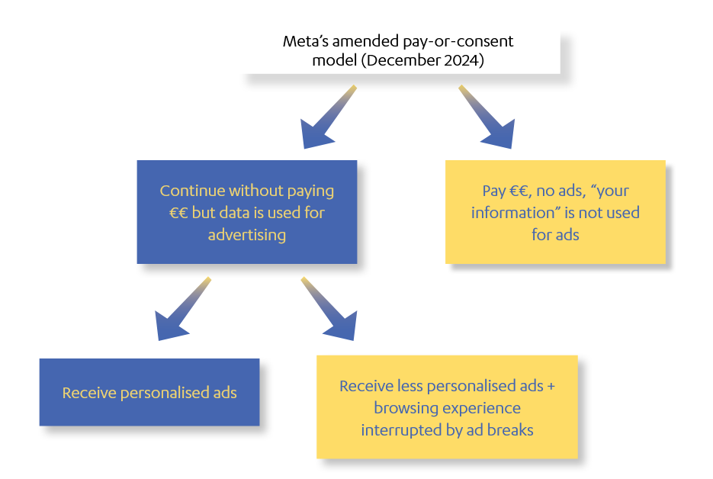
However, this new flow continued to raise several problems. First, the ‘less personalised ads option’ was presented later in the user flow and its description was undermined by unclear and non-neutral language. The interface design and language also misleadingly gave users the impression that the later steps were less important and therefore that users could disregard them. BEUC raised its concerns with the competent authorities in January 2025.
In April 2025, the European Commission found that Meta’s pay-or-consent mechanism from November 2023 breached the DMA, and reserved its decision on the second iteration of the mechanism in place since November 2024. Under the threat of periodic penalty payments by the Commission, Meta introduced minor changes in June 2025 and then further changes in January 2026.
It is this latest iteration (of January 2026) (see full user flow in annex 1), which this document scrutinises. Our assessment is that, although there have been some improvements compared to the previous iterations, most problems remain unresolved. As such, Meta’s consent-for-ads means users are stuck in the mud.

An assessment against the Digital Markets Act

What the DMA requires
Under the DMA, Meta must obtain user consent as laid down under the GDPR (Art. 4 GDPR) in order to use the user’s personal data gathered from third parties for ad purposes (Art 5.2 DMA). In order to give users the possibility to freely opt in to such data processing, Meta must provide them with a less personalised but equivalent alternative. Meta cannot make the use of the service (or certain of its functionalities) conditional on the end user’s consent (Recital 36 DMA). Importantly, the less personalised alternative must not be of a degraded quality, nor should Meta design its online interfaces in a way that deceives, manipulates, distorts or impairs the ability of end users to freely give consent (Recital 37 DMA).
Any behaviour which undermines effective compliance, including the use of behavioural techniques or interface design, or which leads to offering choices in a non-neutral manner or subverts consumers’ choice or free choice, is illegal (Article 13 DMA). Meta must also be able to demonstrate compliance with its obligations (Article 8).
(Note that the requirements for valid consent under the GDPR are presented under the GDPR section in this document).

What has improved and what remains insufficient

 | Meta still fails to provide the ‘less personalised ads’ option upfront and on the same level as the ‘no ads option’ or a ‘personalised ads option’ (see screen 1 and screen 3 in annex 1).  By law, users are entitled to a less personalised option. Yet the current user flow makes it possible for users to select the ‘no ads option’ in the first step without being presented the ‘less personalised ads’ option or holding sufficient information about it to consider this to be a valid option later in the user flow if they select the ‘ads option.’ This is despite the Commission declaring the binary choice between a ‘no ads option’ or ‘personalised ads option’ non-compliant with the DMA in April 2025.  Additionally, by providing the fundamental choice later in the user flow, Meta gives users the impression that the important choice to make is between the ‘no ads option’ and the ‘ads option’. In fact, the key decision is between the ‘personalised ads option’ and the ‘less personalised ads option’. This interface design is likely to distort users’ decision-making, particularly when considering the non-neutral and vague language (see below) Meta later uses to describe the ‘personalised ads option’ and the ‘less personalised ads option.’

Meta provides users who opt for the ‘less personalised ads option’ with a degraded experience by imposing ad breaks which interrupt the user experience. It cannot be argued that the degradation of service is a direct consequence of its inability to process users’ personal data, as the unavailability of certain data does not require the addition of ad breaks.

Meta continues to use elements of non-neutral language and behavioural techniques in its interface design which likely undermine effective compliance and thus breach the DMA. These include describing the ‘personalised ads option’ more favourably than the ‘less personalised ads option’ (see screen 3 in annex 1 for example) and describing the data processing Meta will engage in with either option in vague terms (see screens 2,3 and 4 in annex 1).
Meta also uses the well-known status quo bias to its advantage by requiring users to click away from the ‘personalised ads option’, which is likely to be selected as the default option in the new user flow.
Rather than requiring users to make a new choice regarding the entire flow, Meta sets the default option from the previous flow as the default in this flow too. Given that most users likely never made it to the choice between the ‘personalised ads option’ and the ‘less personalised ads’ option in the previous user flow, and that the default in that user flow was to place users on the ‘personalised ads option’, Meta is able to use the status quo bias to its own advantage by having the ‘personalised ads option’ likely selected by default. This behavioural technique provides an interface design which is non-neutral, thus undermining effective compliance with DMA obligations.
If users wish to revisit their choice, it is now harder to find the choice between the ‘personalised ads option’ and the ‘less personalised ads option’ than it is to find the choice between ‘no ads option’ and the ‘ads option. The use of separate tabs for the two choices makes the former choice less salient and may constitute non-neutral interface design which undermines effective compliance with the DMA.

Meta has not provided any proof that it has tested this user flow with users for neutrality and is therefore unable to demonstrate compliance with the DMA.

 | Meta has removed a particularly misleading step from the previous user flow (Fig. 3). This screen informed users that they were “all set” after having decided between a ‘no ads option’ and an ‘ads option’. This screen was misleading because it likely led many users to discontinue the user flow. Consequently, it is highly likely that a vast majority of users never reached the choice between the ‘personalised ads option’ and the ‘less personalised ads option’ in the previous user flow.  Fig.3: intermediary screen in Meta’s November 2024 user flow which has now been removed  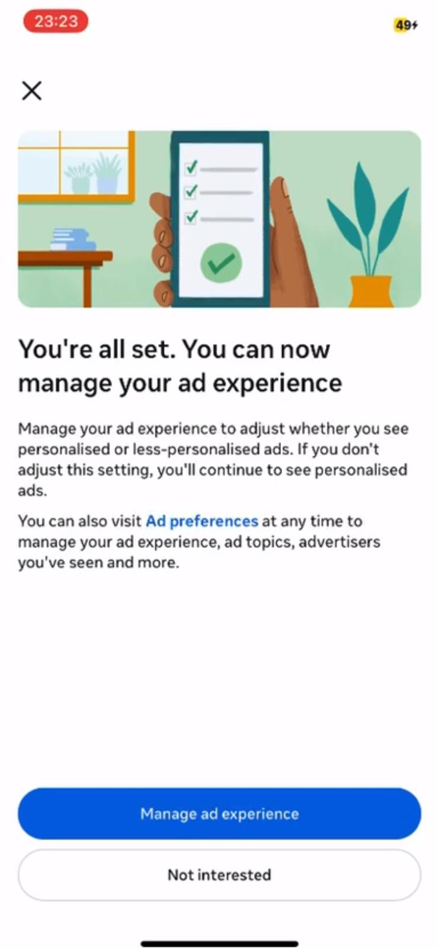

 | BEUC believes the underlying data processing must be limited to the bare minimum and to what is strictly necessary to provide the ‘less personalised ads’ option. However, the information provided by the company is vague. As a result, it is unclear whether Meta’s processing for this purpose complies https://www.facebook.com/help/468797095528474with the DMA/GDPR requirements more broadly. We are concerned that Meta's processing for the less personalised version is still excessive and unnecessary.

It is unclear whether Meta’s new user flow has been rolled out to all Facebook and Instagram users. Any user who has chosen in the past between the ‘no ads option’ and the ‘ads option’ has not been able to provide freely-given consent, given the inherent problems in the designs of the previous user flows.

Assessment against the GDPR

What the GDPR requires
The GDPR is the reference framework for the provision of online consent. The DMA is no exception: any given consent action must comply with the GDPR, even though it is given in the context of a DMA-relevant user flow. Under the GDPR, lawful processing must respect specific data protection principles, including data minimisation. This means that the data collection must be contained within what is strictly necessary. Further, valid consent must be freely given, specific, informed, unambiguous, and as easy to withdraw as it was to give. In general terms, little has changed in the problems BEUC already highlighted in the past. In this sense, we refer entirely to our previous complaints and analyses.

Data minimisation
While the new user flow adopted by Meta may have brought some improvements, all previously highlighted issues remain. For instance, an evident problem persists in terms of data minimisation.

The CJEU (Case C-252/21, Meta Platforms and Others) has already clarified that controllers like Meta must not engage in personalised advertising without any restrictions as to the quantity, time and type of personal data collected and processed. The Commission should investigate this substantive matter further. Without solid evidence that the underlying processing operations are lawful under the GDPR, no valid consent can ever be established.

Informed consent
Providing information to the data subject before obtaining their consent is essential so that they can make an informed decision and understand the processing operations they are consenting to.

The CJEU (Case C-61/19, Orange Romania) has clarified that the requirement for informed consent does not only concern, or is not limited to, the formal information listed in the GDPR. The information provided to the user for this purpose must be clear, unbiased, and must enable them to gain a genuine understanding of the processing operations involved. This includes a duty to inform the user about the underlying processing operations.

Throughout the user experience, however, Meta presents its ‘personalised ads option’ only in a positive light. The information is focused exclusively on the benefits brought by this kind of advertising. The user is never told what operations run in the background to finally obtain those ads. In the entire user flow, there is no mention of Meta's intensive and aggressive tracking of users (see user flow in annex 1).

Further, the use of the expression "free of charge" leads the user to believe that the service is actually free (see screen 2 in annex 1). But this is not true. The advertising system set up by the controller is almost exclusively based on the profit derived from the use, exchange and ultimately exploitation of users' data.

Consequently, the information provided by Meta does not allow the user to verify the actual substance of the underlying processing operations. This is a clear breach of the GDPR.

Freely given consent
The consent requested by Meta is not freely given by users. Under the DMA, read in conjunction with the GDPR, users must be offered a less personalised alternative. This alternative should be "equivalent" to the one provided in case of personalised service. To ensure equivalence, "the alternative service should not differ, in terms of performance, experience and conditions of access compared to the service offered to consenting end users" (emphasis added).

These conditions are not met in the case of Meta. The less personalised alternative is presented in a negative way (see screen 3 and 4 in annex 1). For instance, the sentence "Your ads will be less related to your interests" gives the false impression that the user will have to endure a less enjoyable online experience. Further, the wording "Your browsing may be paused by ad breaks" shows that the service performance may be sub-optimal. Finally, "Your ability to advertise and monetize with ads will be limited" suggests that, by making this choice, a portion of the service will be inaccessible.

In conclusion, Meta connotates the less-personalised alternative in negative terms and by doing so nudges the user into accepting the full tracking. This is a clear breach of the freely given requirement under the GDPR.

An assessment against the Unfair Commercial Practices Directive
Meta still relies on the terms “use free of charge with ads.” In our previous analyses, we took the view that this wording was ambiguous and misleading, and therefore breached Art. 6 of the UCPD. This analysis still holds with Meta’s new model.

The Unfair Commercial Practices Directive Guidance document highlights that presenting “products as ‘gratis’, ‘free’, ‘without charge’ or similar if the consumer has to pay anything other than the unavoidable cost of responding to the commercial practice and collecting or paying for delivery of the item is a commercial practice which is in all circumstances considered unfair and thus prohibited under the UCPD.” It further states that the marketing of such products as ‘free’ without adequately explaining to consumers how their preferences, personal data and user-generated content are going to be used could be considered a misleading practice in addition to possible breaches of data protection legislation.
The CPC-Network, coordinated by the French CPC Authority (Direction Générale de la Concurrence, de la Consommation et de la Répression des Fraudes – DGCCRF) launched a coordinated action against Meta’s subscription model in November 2023, looking in particular at several infringements of EU consumer law acquis. By early 2026, this action is still ongoing.
In parallel, in September 2025, the German Supreme Court (Bundesgerichtshof - BGH) referred a question to the CJEU on the interpretation of the UCPD and specifically as to whether advertising online services as ‘free’ while exploiting user data misleads consumers. This question is therefore expected to be settled in the coming months.

Annex 1
Meta’s user flow from January 2026. All screenshots below were taken in January 2026 for research purposes.

Prompt | Screen 1
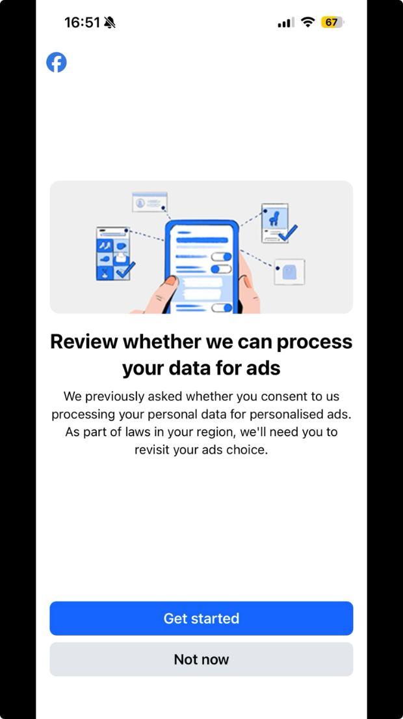 | 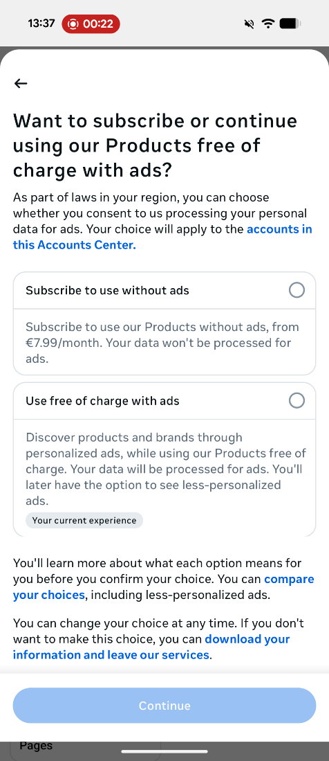

Screen 2 | Screen 3
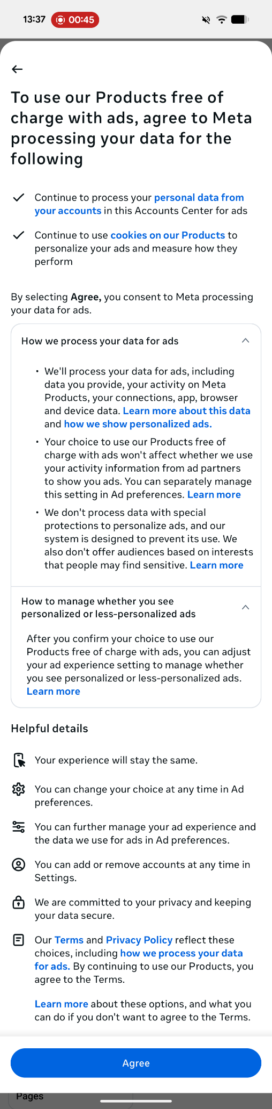 | 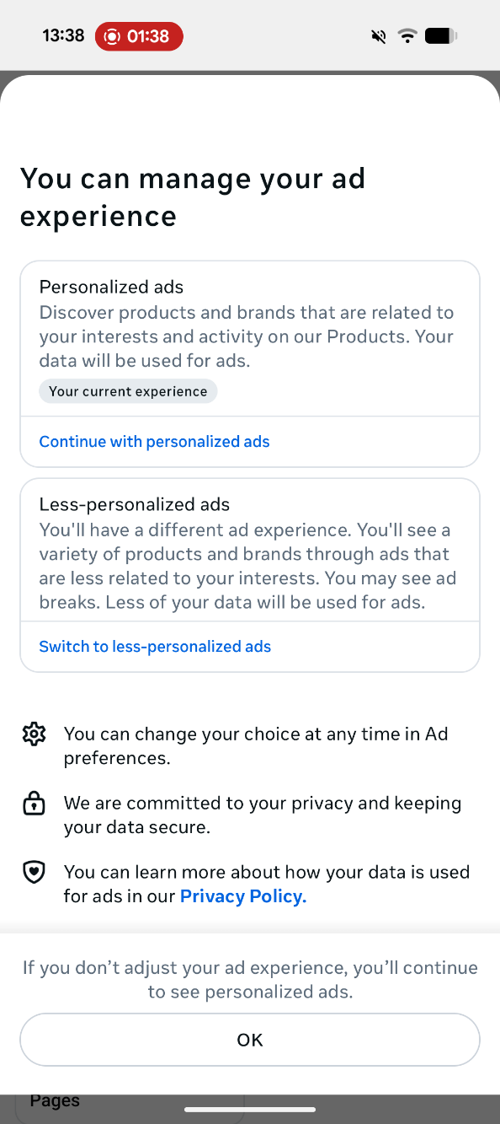

Screen 4
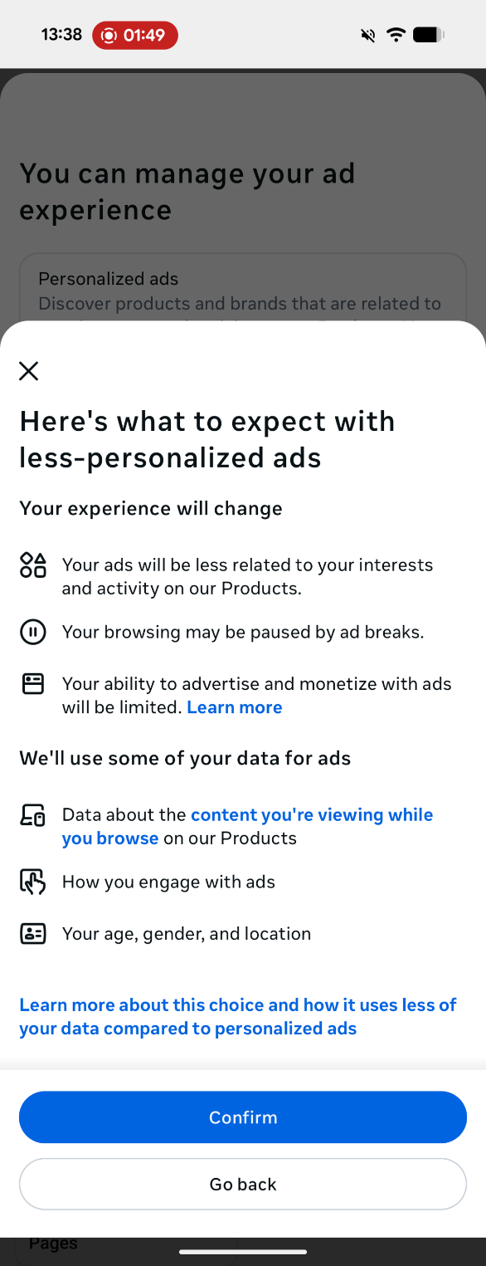

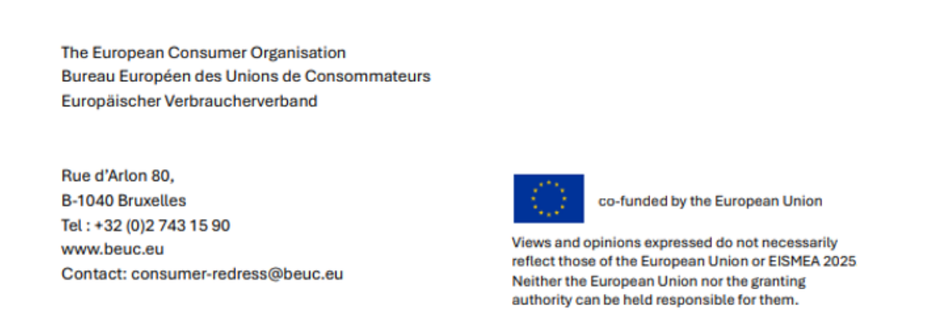

BEUC testing on Android device on 18 January 2024.
CJEU, Judgement : ‘Meta Platforms Inc and Others v Bundeskartellamt’ Case C-252/21 (4 July 2023).
The participating organisations were Асоциация Активни потребители (Bulgaria), dTest (Czech Republic), Forbrugerrådet Tænk (Denmark), UFC-Que Choisir (France), EKPIZO & KEPKA (Greece), Adiconsum (Italy), Latvijas Patērētāju interešu aizstāvības asociācija (Latvia), Vartotojų aljansas (Lithuania), Consumentenbond (Netherlands), Forbrukerrådet (Norway), Federacja Konsumentów & Fundacja Konsumentów (Poland), Spoločnosť ochrany spotrebiteľov (S.O.S.) Poprad (Slovakia), ZPS (Slovenia), Asufin & CECU (Spain), Sveriges Konsumenter (Sweden), Union Luxembourgeoise des Consommateurs (Luxembourg).
The participating members were dTest (Czech Republic), Forbrugerrådet Tænk (Denmark), EKPIZO (Greece), UFC-Que Choisir (France), Forbrukerrådet (Norway), Spoločnosť ochrany spotrebiteľov (S.O.S.) Poprad (Slovakia), Zveza Potrošnikov Slovenije – ZPS (Slovenia) and CECU (Spain).
Art. 5 GDPR.
The CJEU takes this position in its decision C-446/21 (Schrems v Meta). In parallel, the EDPB Opinion highlighted that the processing of personal data for advertising purposes by large online platforms like Meta should be scrutinised very carefully. In particular, the EDPB noted that “the magnitude and intrusiveness of the processing have to be taken into account while assessing compliance with the principle of data minimisation”. Excessive tracking “is thus harder to reconcile with the principle of data minimisation than, for example a system of personalised advertising in which users themselves actively and consciously determine their own preferences". From this angle, nothing seems to have changed.
The Court clarified that information "must enable the data subject to be able to determine easily the consequences of any consent" and "ensure that the consent given is well informed". Even more clearly, the Judges argued that the controller must be able to prove that the "clause was actually read and digested." (emphasis added) (CJEU, 11 November 2020, Orange Romania. v Autoritatea Națională de Supraveghere a Prelucrării Datelor cu Caracter Personal (ANSPDCP), C-61/19, paragraphs 40 and 46).
In its Opinion on Valid Consent in the Context of Consent or Pay Models Implemented by Large Online Platforms, the EDPB follows the instructions of the CJEU and uses very clear words. Controllers have the responsibility, under the principle of accountability, to build up an information process enabling data subjects to have a full and clear comprehension of the consequences of their possible choices. "This includes a duty to inform users of processing activities that run in the background and of which they may not be aware. If the appropriate information is not provided, an information asymmetry may occur and data subjects may not be able to foresee the manner in which their personal data will be processed" (emphasis added) (Adopted on 17 April 2024, paragraphs 143, 145, and 147).
In our previous submissions, we have already clarified how META's dominant position within the specific market sector makes the element of detriment particularly significant for a free consent.
EC/EDPB, Joint Guidelines on the Interplay between the Digital Markets Act and the General Data Protection Regulation, paragraph 26
European Commission, ‘Guidance on the interpretation and application of Directive 2005/29/EC of the European Parliament and of the Council concerning unfair business-to-consumer commercial practices in the internal market’ C/2021/9320 (29 December 2021).
BGH, Beschluss vom 25. September 2025 – Az. I ZR 11/20
BEUC testing on Android Pixel 9a device on 28 January 2026.

