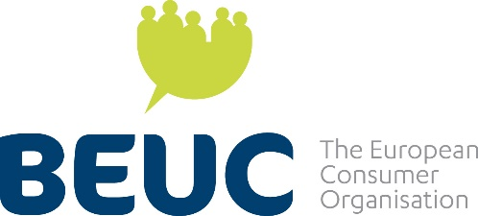  The Consumer Voice in Europe | Mr. Erik Slottner  Minister for Consumer Affairs  Ministry of Finance  Sweden
Ref.: BEUC-L-2023-194/MGO/CPO/hbu 22 September 2023

Subject: Sustainability of the consumer movement in Sweden

Dear Minister of Consumer Affairs,

I am writing on behalf of BEUC, The European Consumer Organisation which is the umbrella group for 45 independent consumer organisations from 31 countries. Our main role is to represent them to the EU institutions and defend the interests of European consumers. Our member in Sweden is Sveriges Konsumenter.

We have recently been informed that the 2024-2026 budget of the Swedish government, in its present form, provides for a drastic phasing out, leading to cancellation of state support to our Swedish member.

Sveriges Konsumenter is a long standing and very active member of BEUC ever since its foundation in 1992. A stable state support to represent Swedish consumers in the EU has been there over many different Swedish governments in now over 30 years. This in line with the intention of creating a national consumer organisation as a result of Sweden’s EU membership.

European Consumer Policy is increasingly important and needs the national consumer perspectives to provide inclusive solutions for consumers across the EU. This has been stated repeatedly by the European Consumer Programmes.

Sveriges Konsumenter has been vital to the evolvement of a strong European Consumer Voice both as member of BEUC, ANEC (Our sister organization for the Consumer voice in standards) and the different European Commission consultative committees/groups over the years. Sveriges Konsumenter has provided executive functions as former president of BEUC and former vice president of ANEC.

Funding of consumer organisations is different throughout the Union but the ones relying on state support do so for a reason and need long term commitment from governments. In the case of Sweden, it is my understanding that the main business model for consumer organisations of providing consumer advice is by tradition free and organized by municipal and state agency services. This among other national specificities makes it hard to find a viable business model for a stable consumer organisation to represent consumers.

A consumer organisation cannot like other NGOs accept money from businesses. Also, project funding is not given to regular representative tasks and most often requires own contribution to a percentage which is not possible without a stable base funding.

…/…

Sweden has a strong reputation for responsible consumer policy, and it is more crucial than ever, in these times of green and digital transitions, that this can be maintained as a model for all European consumers. That is why we strongly encourage you to continue to support the standing of Sveriges Konsumenter as a strong consumer advocate, both at national and EU level.

Yours sincerely,

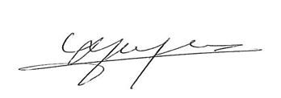
Monique Goyens
Director General

